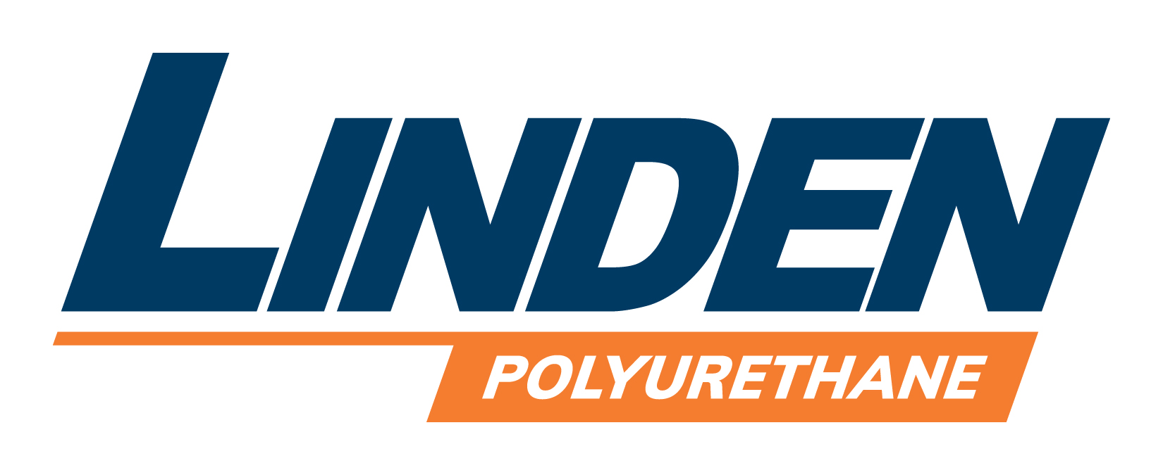 is Hiring . . .

Job Description

Job Title: OD grinder / Hone operator

Company: With 25 plus years of Polyurethane Processing Equipment Design, Engineering and Manufacturing experience, Linden Industries is a market leader that can supply a complete turn-key systems as well as world class repair services. Linden specializes in all applications requiring Polyurethane Foam, RIM, Elastomers and Urethane coatings. From 3 g/sec to 8 lbs. /sec, their Engineers will design the right system for highest efficiency possible.

Linden Industries Service Department provides customer acclaimed 24/7 support on all Linden Polyurethane Processing Equipment. Additionally by making special arrangements through our Service Department, Linden Service Technicians are available to work on all brands of Polyurethane Equipment. Our Repair Department specializes in Rexroth and Rotary Power metering pump repairs and all OEM brands of polyurethane mixing heads.

Come visit our website to learn more about us: www.linden.com

Location: Cuyahoga Falls, Ohio

Benefits: At Linden, we put people first. You will be eligible for the same benefits (medical, vision, dental, retirement, life insurance) as the other employees of Linden. Please let us know what, if any, information you’d like to review regarding our comprehensive benefit program.
- Competitive wage
- Company supported Health Insurance
- 401k match program
- Life insurance

Job Brief: We are looking for an experience OD grinder / Hone operator.

This position requires attention to detail and ability to work well with others.

Qualifications:
- High school graduate
- 5-10 years relevant experience
- Positive attitude and a track record of good performance
- Clean Valid driver’s license

Duties & Skills:
- Established machine shop seeks experienced OD grinder / Hone operator.
- Duties will include OD grinding on an NC controlled machine and honing of small bores using a Sunnen 1804 hone.
- Some light assembly / fitting work also required.
- Good organizational and cleanliness skills a plus.
- Basic knowledge of grinding / honing a must but will train the right candidate.
- Read, interpret and understand all different kinds of mechanical drawing assemblies, blue prints & specification sheets.
- Check and clean work pieces and work areas
- Confer with engineering, supervisory, and manufacturing personnel in order to exchange technical information.
- Accept constructive criticism and use it to improve performance
- Be a team player and work well with others
- Willing to do a bit extra to get a job done right and on time
- Have a customer focused mentality

Contact Jackie Nagle at 330-971-7739 for more information

